

**Samsung Anglia Training Workshop**

TABLE OF CONTENTS

Introduction 2

ARTIK530s Set Up 4

ARTIK530s Hardware setup 4

Setting up the Terminal Console 5

ARTIK530s Activation 5

Configure WiFi on ARTIK 530s 6

Lab 1: Stream Telemetry Data from ARTIK055s to ARTIK530s 8

1.1 Install ARTIK IDE/SDK 8

1.2 Create an Application for ARTIK055s 8

1.3 Adapt the Application 11

1.4 Stream sensor data to ARTIK530s gateway device via MQTT 12

1.5 Listen to incoming messages on ARTIK 530s 14

Lab 2: Connect to ARTIK Cloud (Bonus) 16

Lab 3 Secure MQTT communication between ARTIK055s and 530s 21

2.1 Generate a cert/key pair on 530s 21

2.2 Configure the certificate on ARTIK 055s 22

# Introduction

This hands-on lab shows how you can build a small demo by using ARTIK 055s and 530s.

In the lab, we explain how to use ARTIK055s to collect button readings, stream it to ARTIK 530s via MQTT. On ARTIK 530s. From there you can also aggregate data for visualization and stream to cloud.

Connect ARTIK 055s development board to your host machine using an USB cable.

On Windows host machine:

1. Find your serial device in your Device Manager / Ports and remember the COM port your ARTIK board is using. In our example, the board uses COM4 port.

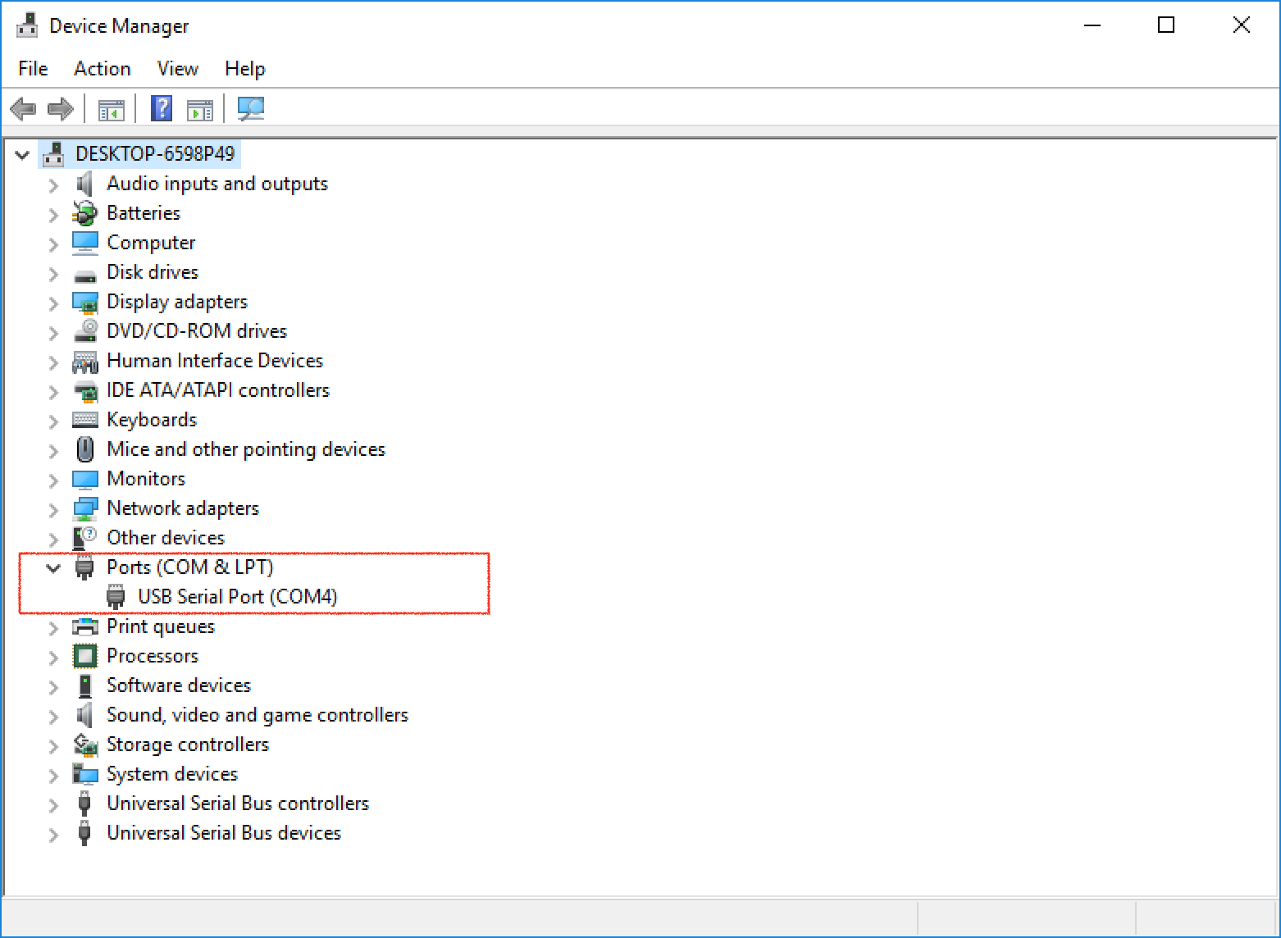

1. Please install and launch a serial console application PuTTY.. Select “Serial” as the Connection type, use the COM port number you find from Device Manager and Speed 115200 for serial access.

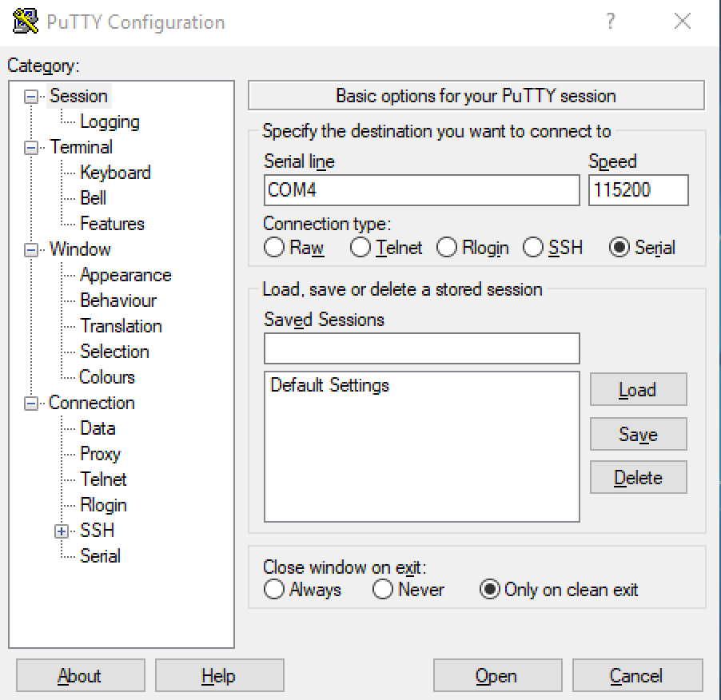

1. For Windows users, Please

* Browse to the ARTIK_IDE_Installation_Directory\tools directory.
* Run the zadig-2.3.exe application.
* Under **Options**, select **List All Devices**.
* Under the devices drop-down list, select Interface **1** of the dual COM port
* Update the driver to the WinUSB driver by clicking **Replace Driver**.
* Now select Interface **0** of the FTDI device, and change it to a `libusb` driver.

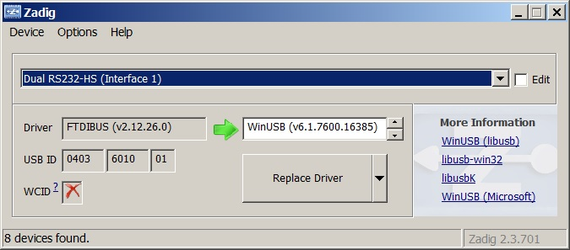

On Mac host machine:

For Mac users, you can use the built-in *screen* utility to access the serial console. Normally the device name ends with 141B or 142B.

screen /dev/cu.usbserial-XXXXXXX 115200

# ARTIK530s Set Up

## ARTIK530s Hardware setup

1. We provide two antennas for ARTIK530s developer kit, one for ZigBee and one for WiFi. They are identical and interchangeable. Please connect the interface board and mount your antennas as shown below:

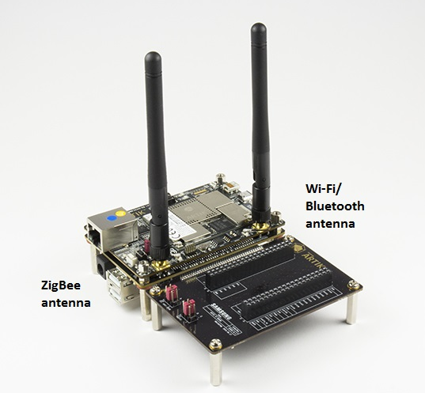

1. Plug in USB cable for serial access. Connect the other end of the USB cable to your laptop.

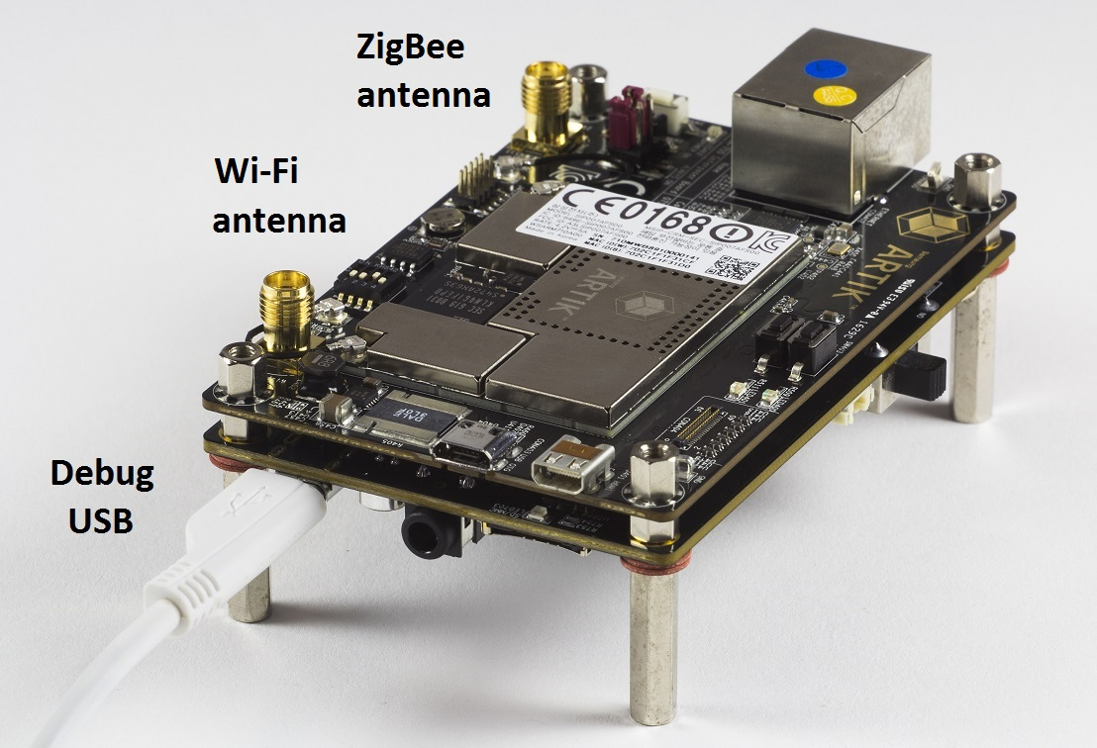

1. Make sure the power switch on the development board is set to the off position. Plug in the power supply to the development board.

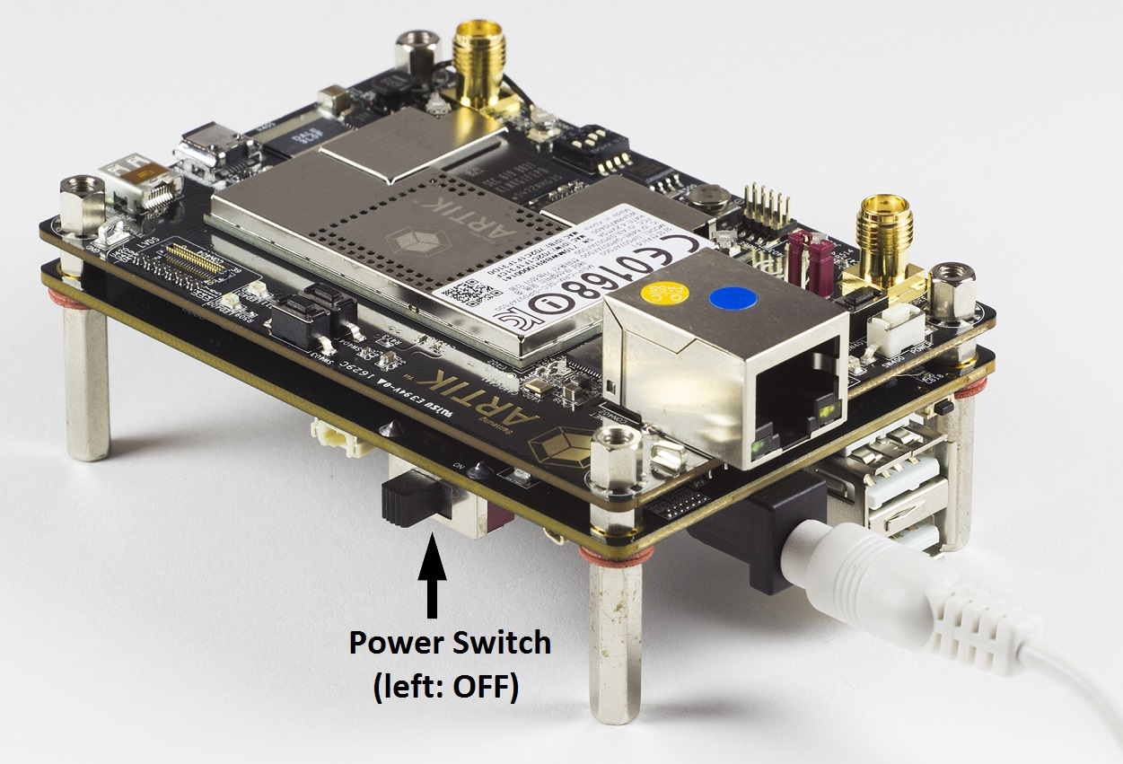

## Setting up the Terminal Console

Please follow this tutorial to set up your terminal console.

<https://developer.artik.io/documentation/developer-guide/artik-ide/serial-debug.html>

## ARTIK530s Activation

After you first apply power, you’ll need to activate the board with a 1-second reset pulse using the POWER push-button switch, located as shown for ARTIK530 board.

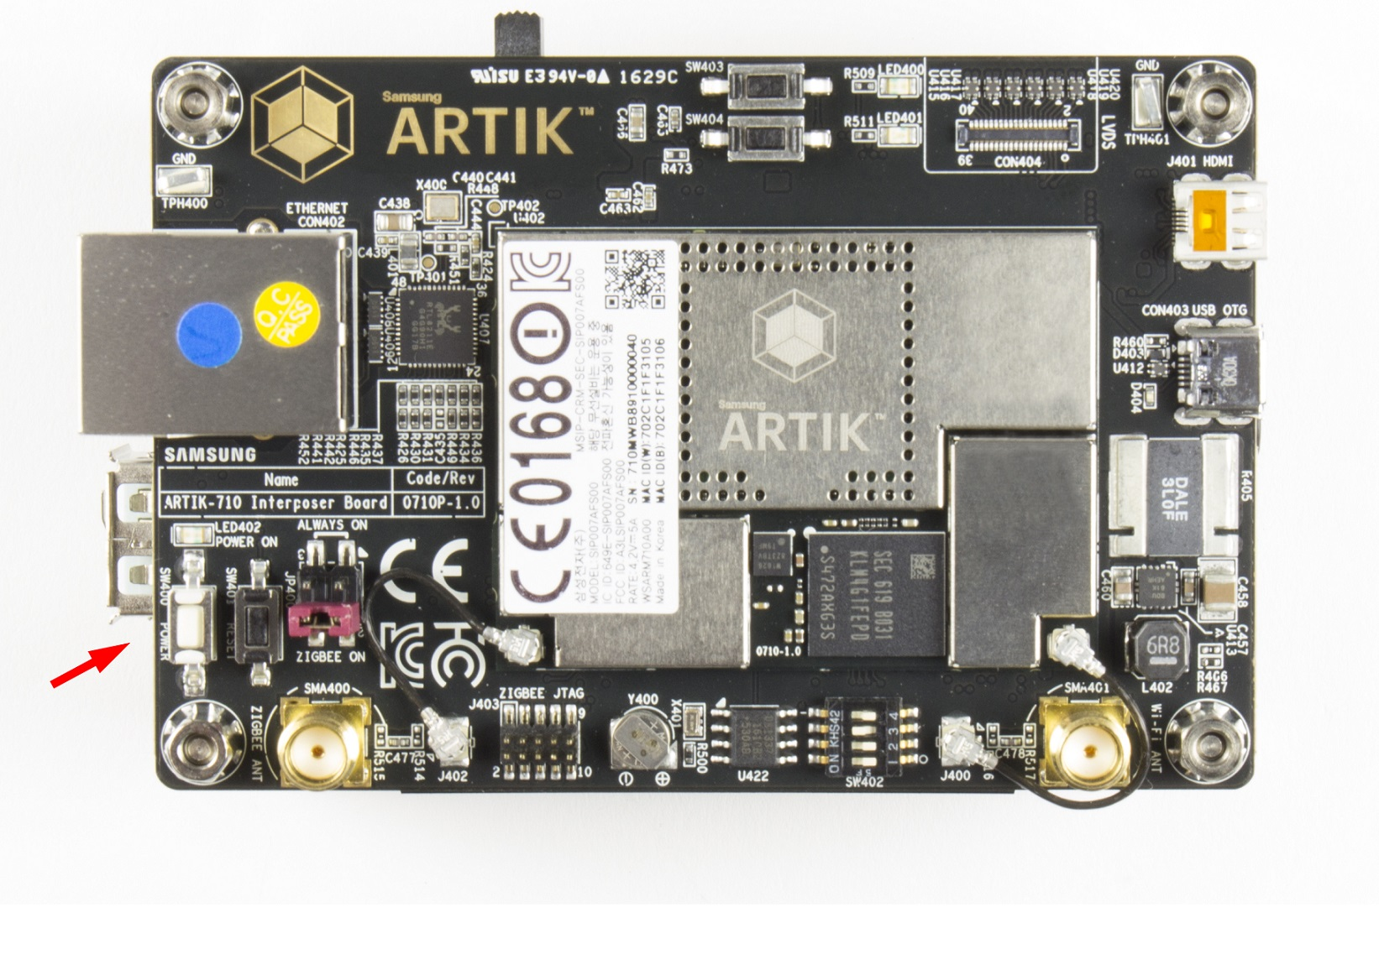

## Configure WiFi on ARTIK 530s

In this step, we will configure the wpa_supplicant.conf file to include your WiFi router settings. Please replace SSID and PASSWORD in the first command below by using your own configuration.

[root@artik ~]# wpa_passphrase "SSID" "PASSWORD" >> /etc/wpa_supplicant/wpa_supplicant.conf

[root@artik ~]# cat /etc/wpa_supplicant/wpa_supplicant.conf

ctrl_interface=/var/run/wpa_supplicant

ctrl_interface_group=netdev

network={

ssid="SSID"

#psk="PASSWORD"

psk=c2161655c6ba444d8df94cbbf4e9c5c4c61fc37702b9c66ed37aee1545a5a333

}

Use ‘cat /etc/wpa_supplicant/wpa_supplicant.conf’ to make sure your settings have been included into the configuration file properly.

Restart wpa_supplicant and use dhclient to obtain an IP address

[root@artik ~]# systemctl restart wpa_supplicant

[root@artik ~]# dhclient wlan0

Now, your ARTIK530s board should have an IP address associated with wlan0 interface. Take a note of your ARTIK530s wlan0 IP address.

[root@artik ~]# ifconfig wlan

wlan0 Link encap:Ethernet HWaddr 00:50:43:02:fe:01

inet addr:**10.0.1.51** Bcast:10.0.1.255 Mask:255.255.255.0

inet6 addr: fe80::250:43ff:fe02:fe01/64 Scope:Link

inet6 addr: 2601:646:8881:4923:250:43ff:fe02:fe01/64 Scope:Global

inet6 addr: 2601:646:8881:4923:99af:2c8:df37:ceca/64 Scope:Global

UP BROADCAST RUNNING MULTICAST MTU:1500 Metric:1

RX packets:51 errors:0 dropped:0 overruns:0 frame:0

TX packets:79 errors:0 dropped:0 overruns:0 carrier:0

collisions:0 txqueuelen:1000

RX bytes:7177 (7.1 KB) TX bytes:11851 (11.8 KB)

Run ping command to make sure your WiFi connection is live.

[root@artik ~]# ping www.google.com

PING www.google.com (172.217.11.68) 56(84) bytes of data.

64 bytes from lax17s34-in-f4.1e100.net (172.217.11.68): icmp_seq=1 ttl=53 time=21.2 ms

64 bytes from lax17s34-in-f4.1e100.net (172.217.11.68): icmp_seq=2 ttl=53 time=20.6 ms

64 bytes from lax17s34-in-f4.1e100.net (172.217.11.68): icmp_seq=3 ttl=53 time=23.1 ms

64 bytes from lax17s34-in-f4.1e100.net (172.217.11.68): icmp_seq=4 ttl=53 time=19.6 ms

64 bytes from lax17s34-in-f4.1e100.net (172.217.11.68): icmp_seq=5 ttl=53 time=19.8 ms

# Lab 1: Stream Telemetry Data from ARTIK055s to ARTIK530s

In this exercise, we will read ARTIK 055s button state, and stream the state to an ARTIK 530s by using MQTT.

The buton we will use in this exercise is button SW703, which connects to gpio44.

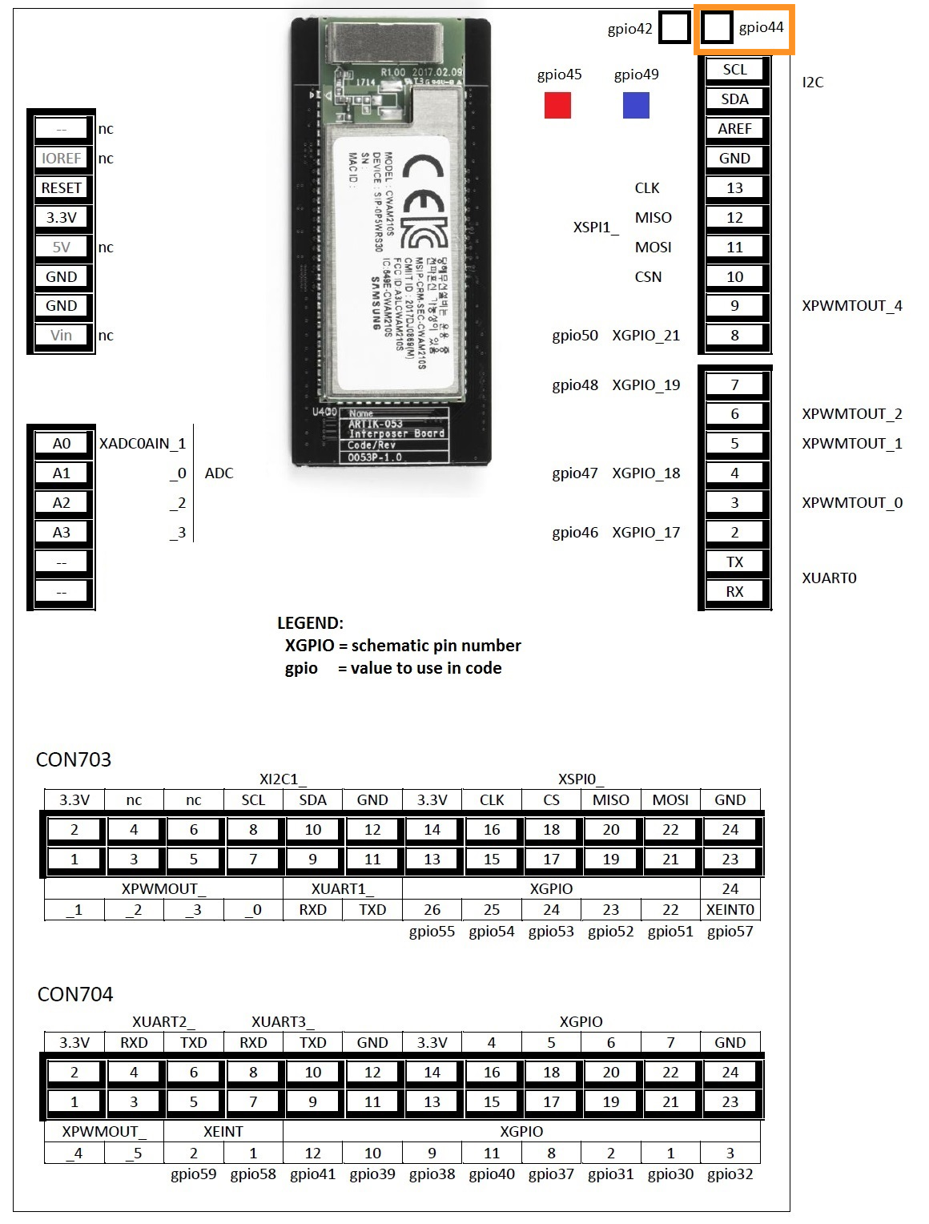

## 1.1 Install ARTIK IDE/SDK

As a prerequisite, you should have installed ARTIK IDE on your host machine. If you haven’t done so, please follow the instructions at <https://developer.artik.io/documentation/developer-guide/artik-ide/install-ide.html> to set up your development environment.

## 1.2 Create an Application for ARTIK055s

1. Launch your ARTIK IDE, go to File->New->C Project.
2. In the “C Project” dialog, select “ARTIK 055s C project”, and choose “gcc-arm-none-eabi” as the default toolchain. Name the Project name as “SensorStreaming”. Then, click Next.

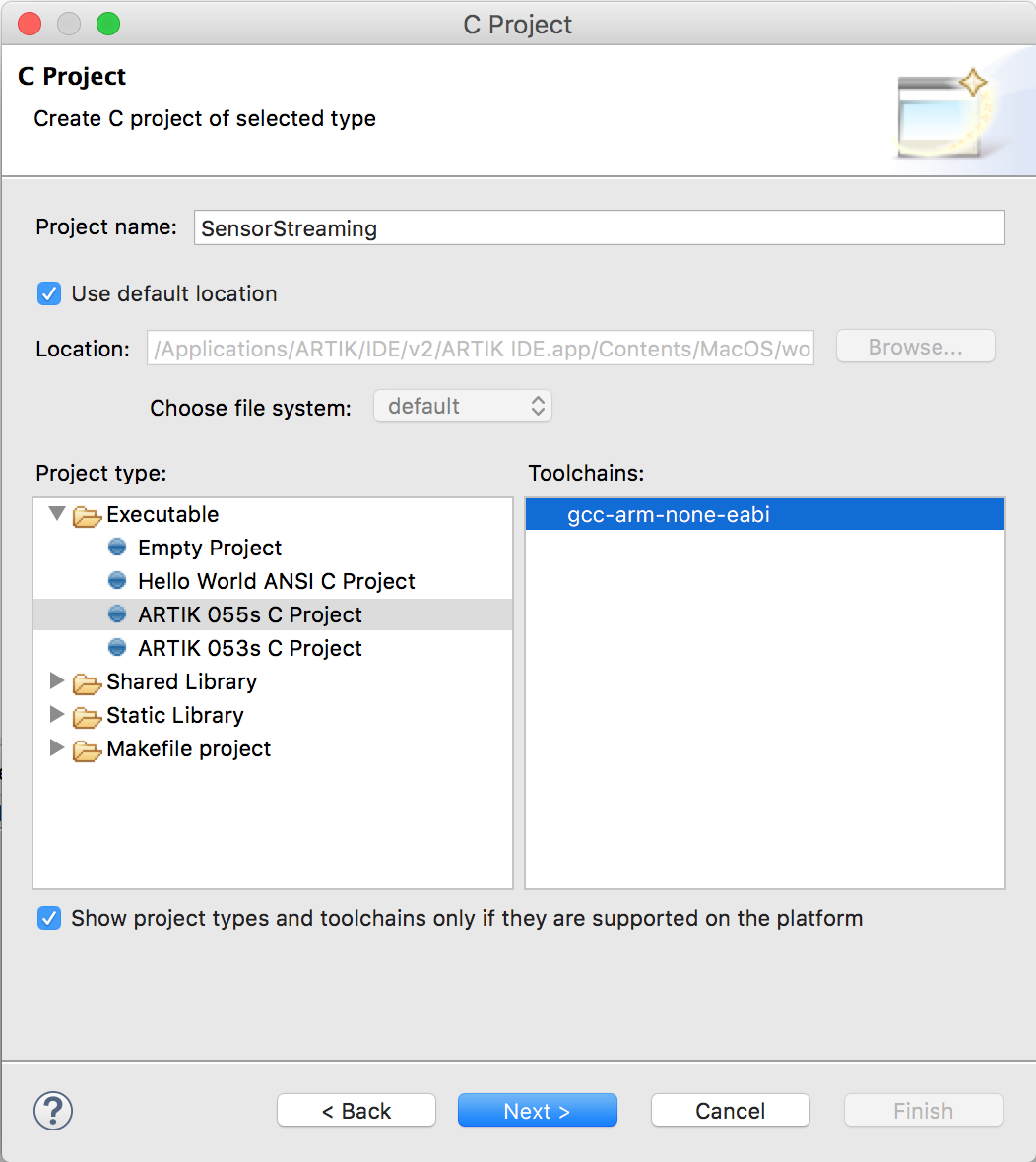

1. In “SDK, Toolchain and Project Selection” dialog, select “ARTIK 05x TizenRT SDK 18.05.00” as the target SDK version. Click on “Artik SDK Examples”, we will use this example as our template to generate an application for sensor data collecting. Then, click Next.

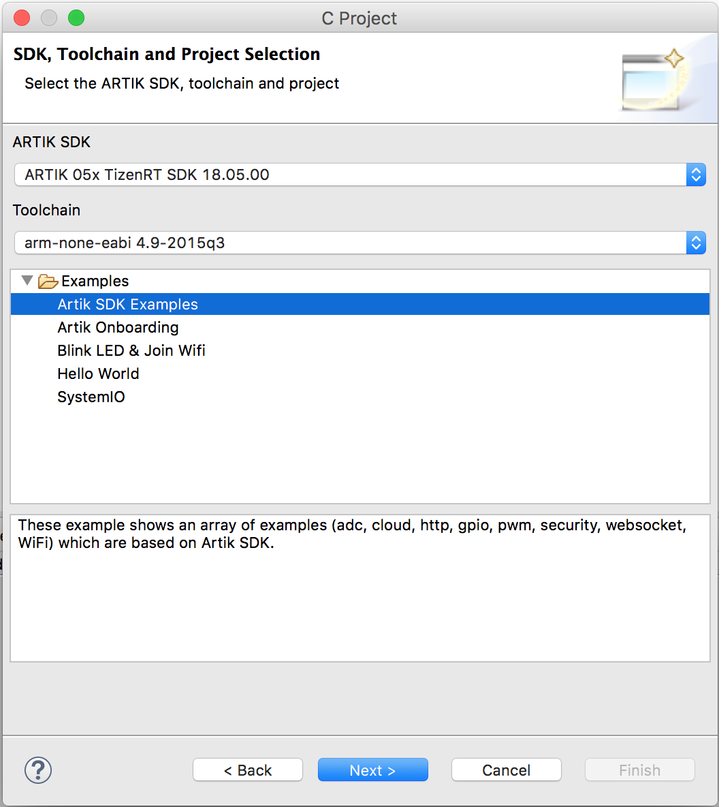

1. In “Tizen RT Application Configuration” dialog, use the default Priority level and Stack Size settings. Change the Pre-build configuration to “extra”, then click Next.

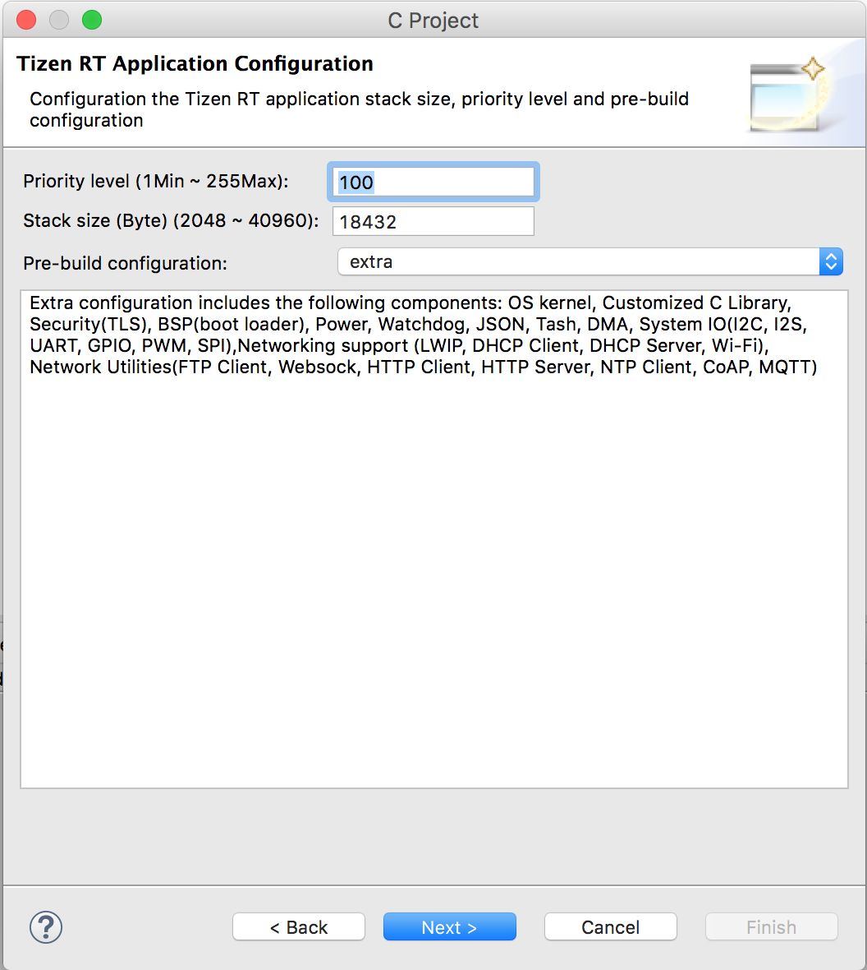

1. In “Select Configurations” dialog, keep the default Debug and Release builds settings, and click Finish.

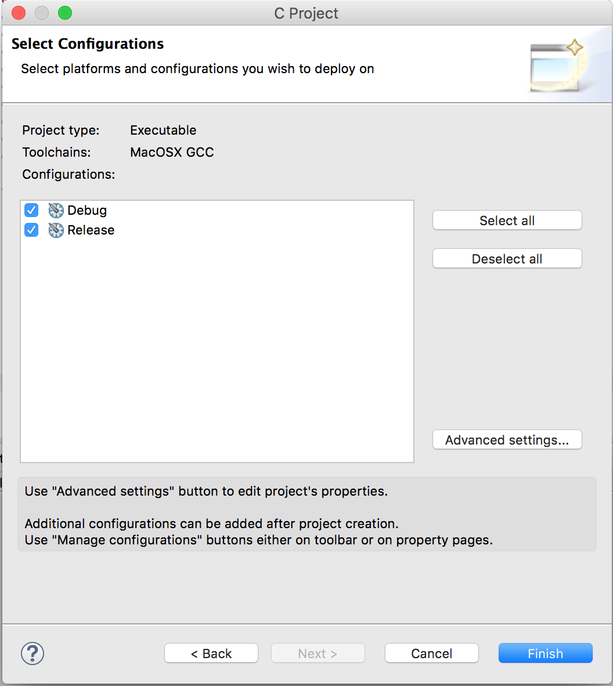

1. Now you have an application ‘SensorStreaming’ created in your IDE Project Explorer.

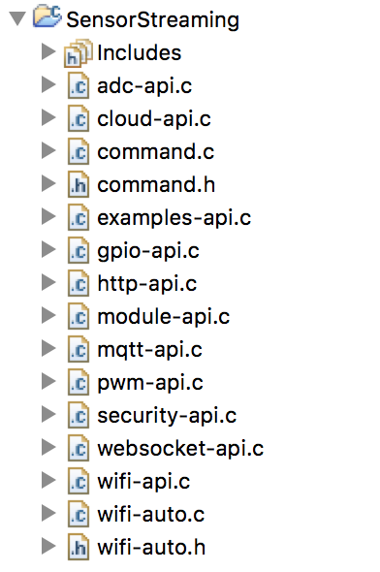

## 1.3 Adapt the Application

1. Open wifi-auto.c, look for WIFI_SSID at the beginning of the file, and configure SSID/PWD by using the credentials of your own router.

#define WIFI_SSID "YOUR_SSID"

#define WIFI_PASSPHRASE "YOUR_PASSWORD"

2. Replace mqtt-api.c by using the version we provided. Drag and drop the file to SensorStreaming project. When you are prompted to overwrite existing file, click Yes to proceed.

3. Build the application by selecting Project->Build Project. You can see the build log from the IDE Console tab.

4. Once you have a successful build, click the “Flash System Image” button to flash the newly built image to the board.

As a precaution, a warning dialog will pop up to confirm you want to flash the connected ARTIK device. Click “Yes” to proceed.

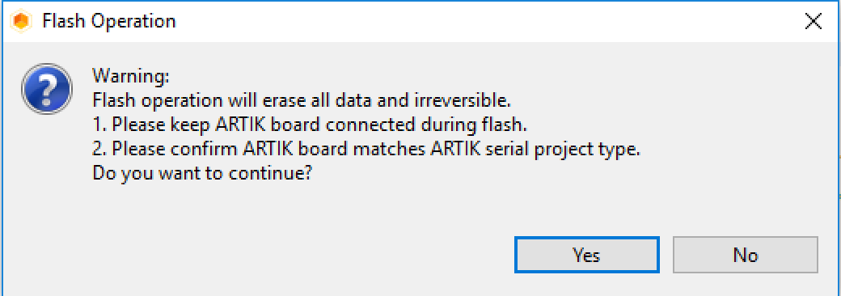

5. From your IDE console, you can view the flash progress.

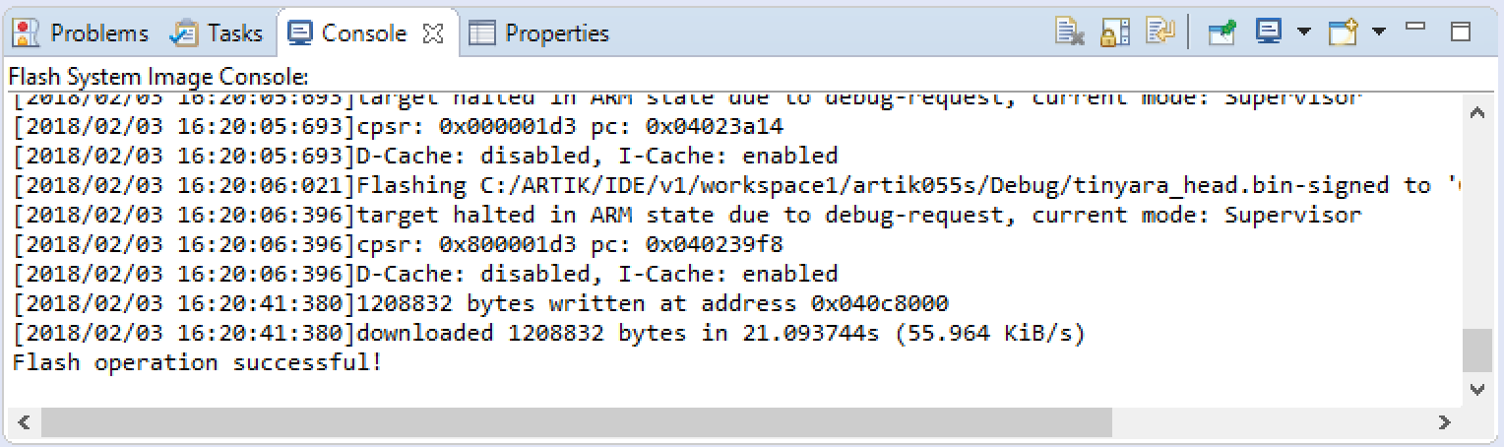

## 1.4 Stream sensor data to ARTIK530s gateway device via MQTT

1. Push the Reset button.

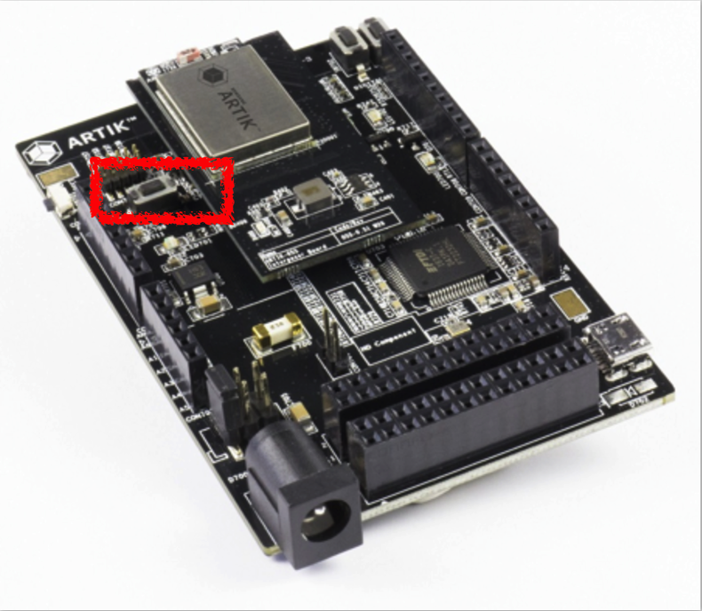

1. From your serial console, you should be able to see the message below when the board boots up.

U-Boot 2017.01-00013-g814fa7d (Jan 08 2018 - 15:17:26 +0900)

CPU: Exynos200 @ 320 MHz

Model: ARTIK-05x based on Exynos T20

DRAM: 1.3 MiB

WARNING: Caches not enabled

BL1 released at 2017-3-13 15:00

SSS released at 2017-09-12

WLAN released at 2017-12-21

Flash: 8 MiB

*** Warning - bad CRC, using default environment

In: serial@80180000

Out: serial@80180000

Err: serial@80180000

Autoboot in 50 milliseconds

gpio: pin gpg16 (gpio 46) value is 1

## Starting application0at 0x040C8020 ...

s5j_sflash_init: FLASH Quad Enabled

i2c_uioregister: Registering /dev/i2c-0

i2c_uioregister: Registering /dev/i2c-1

System Information:

Board: ARTIK053S

Version: 1.0.12

Commit Hash: d1dfb56208b5897ac852a713b6f760ce4efdbd7a

Build User: ARTIK@Samsung

Build Time: 2018-07-17 15:58:54

System Time: 01 Jan 2010, 00:00:00 [s] UTC Hardware RTC Support

ARTIK SDK version: 1.8.0

TASH>>

3. From the ARTIK 055s TASH shell, connect to the MQTT broker running on ARTIK710. Use your ARTIK530’s IP address to replace the one below. Press <Enter> to continue.

TASH>>mqtt connect *<YOUR_ARTIK530_IP_ADDRESS>*

Starting supplicant in foreground...

Connected to ARTIK

Client mosq/;L<pQ^K@gIIb3Xt11u sending CONNECT

TASH>>Client mosq/;L<pQ^K@gIIb3Xt11u received CONNACK

MQTT connection result: OK

4. Publish sensor telemetry data to ARTIK530s by running ‘mqtt publish’.

TASH>>mqtt publish

The value read in GPIO 44 is 1

MQTT: publish 1 on Machine

Client mosq/pMM]H:su<IukdtR=\V sending PUBLISH (d0, q0, r0, m1, 'Machine', ... (1 bytes))

MQTT message published: 1

The value read in GPIO 44 is 1

MQTT: publish 1 on Machine

Client mosq/pMM]H:su<IukdtR=\V sending PUBLISH (d0, q0, r0, m2, 'Machine', ... (1 bytes))

MQTT message published: 2

The value read in GPIO 44 is 0

MQTT: publish 0 on Machine

Client mosq/pMM]H:su<IukdtR=\V sending PUBLISH (d0, q0, r0, m3, 'Machine', ... (1 bytes))

MQTT message published: 3

The value read in GPIO 44 is 1

MQTT: publish 1 on Machine

## 1.5 Listen to incoming messages on ARTIK 530s

On ARTIK530s, we will implement a Python script subscriber.py that listens for incoming messages from ARTIK055s.

The script looks like below:

import paho.mqtt.client as mqtt

import datetime

import time

def on_connect(client, userdata, flags, rc):

print("Connected with result code "+str(rc))

client.subscribe("Machine")

def on_message(client, userdata, msg):

# Use utc as timestamp

receiveTime=datetime.datetime.utcnow()

message=msg.payload.decode("utf-8")

print("New reading: " + str(message) + ", received at " + str(receiveTime))

# Initialize the MQTT client that should connect to the Mosquitto broker

client = mqtt.Client()

client.on_connect = on_connect

client.on_message = on_message

connOK=False

while(connOK == False):

try:

client.connect("localhost", 1883, 60)

connOK = True

except:

connOK = False

time.sleep(2)

# Blocking loop to the Mosquitto broker

client.loop_forever()

Run ‘python subscriber.py’ from the serial console.

# Lab 2: Connect to ARTIK Cloud (Bonus)

In this lab, we are going to create a device type in ARTIK Cloud. Once you have the device type, we will show you how to connect to this device type from your ARTIK devices in the following labs.

1. Open the Developer portal of ARTIK Cloud by using this URL <https://developer.artik.cloud/> or by clicking on “ARTIK CLOUD DEVELOPERS” from ARTIK Cloud user portal.



2. Click on Device Types



3. Click on “+NEW” button



4. Give your device type a Device Display Name such as “your_company lab device” (eg. ARTIK lab device ) and give it an unique name such as com.your_company.your_project_device (eg. com.samsung.artik055) , then click on “CREATE DEVICE TYPE”. This will enable us to create a digital representation for our device type in ARTIK Cloud. (compare this to reserving a name space for a data type in programing languages)

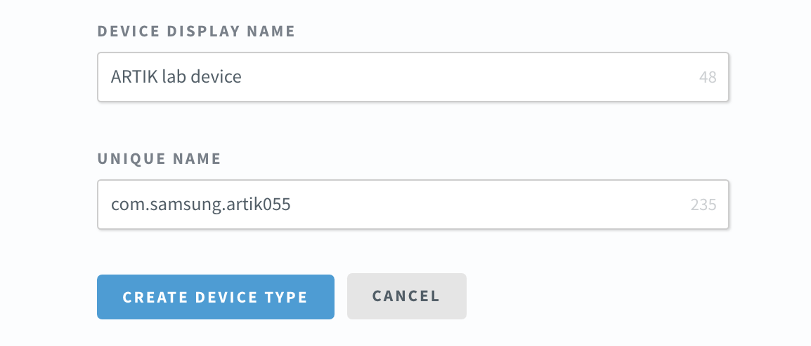

1. Now a name space is reserved for the device type. Actual definition of the device type needs to be done further. This is done using a **Manifest**. A Manifest is the representation of a device’s data properties in ARTIK cloud. Any data, a device produces and sends to ARTIK cloud are represented as “Device Fields”. Any data, the device can respond to is represented as “Actions”. An action can have parameters as well, like an argument.

A Manifest can be created step-by-step using an intuitive user interface or by simply uploading from a JSON file. The steps below explain the creating a Manifest from a JSON file.

To create a manifest from a JSON file, select UPLOAD A MANIFEST.

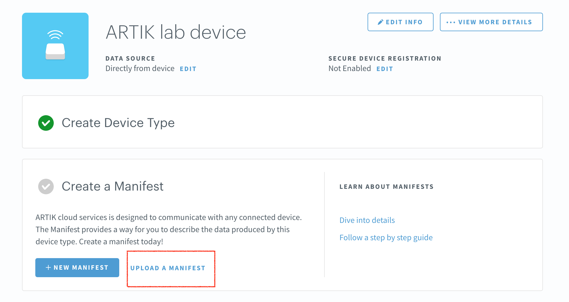

1. Upload the provided manifest file (com.samsung.artik055.json), for reference the contents of the manifest file is available in the appendix A

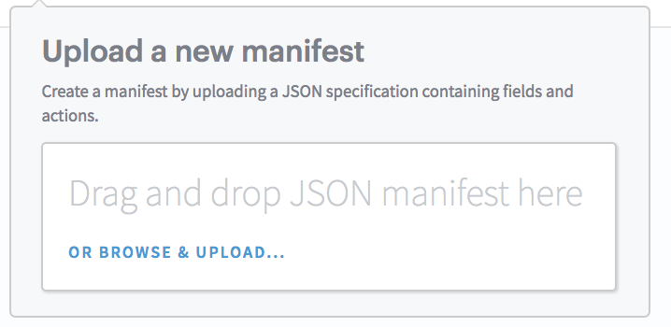

1. Upon uploading the JSON file, make sure the Manifest is as shown below. This Manifest represents a device that can send data to ARTIK Cloud for LED state, distance sensor reading and a timestamp. And it can also receive “setOn” and “setOff” actions from ARTIK Cloud in order to toggle the LED on the board.

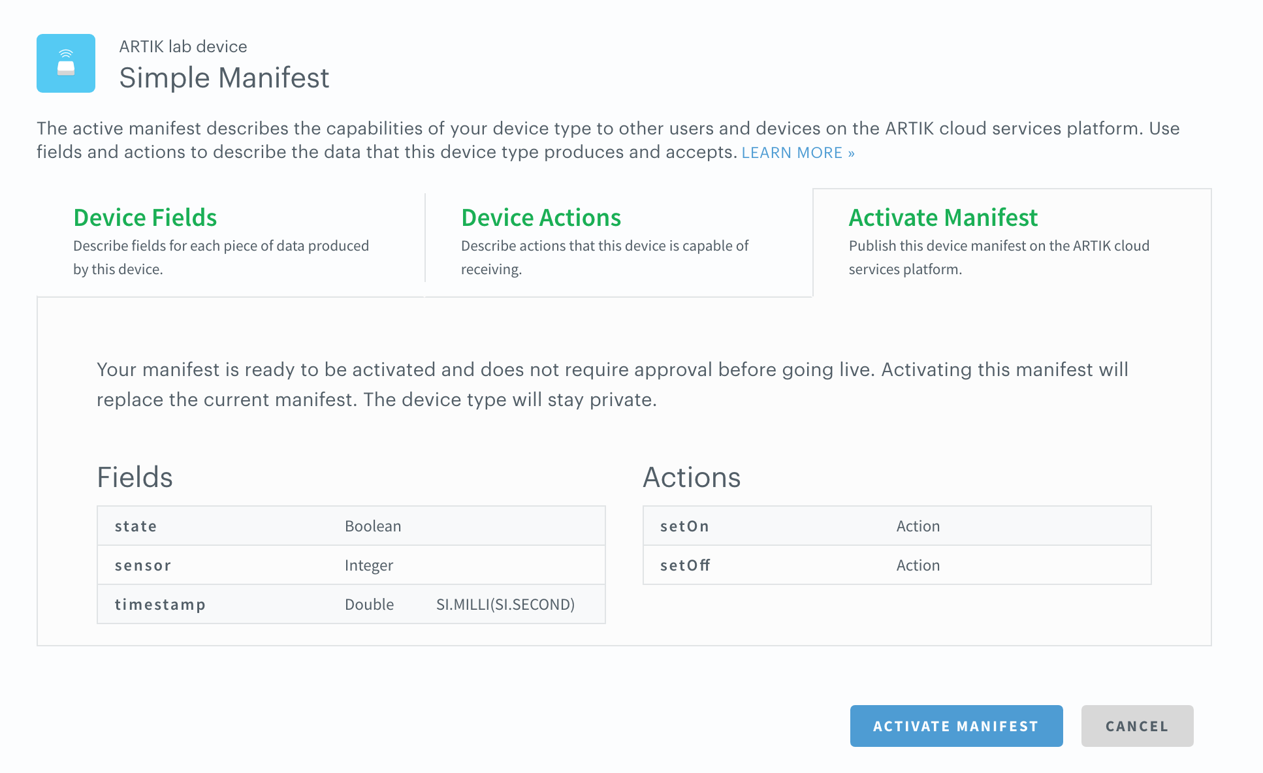

1. Then activate the manifest, by clicking on the “ACTIVATE MANIFEST” button.
2. Make sure a device type is created. Access “VIEW MORE DETAILS” and copy the device type ID created

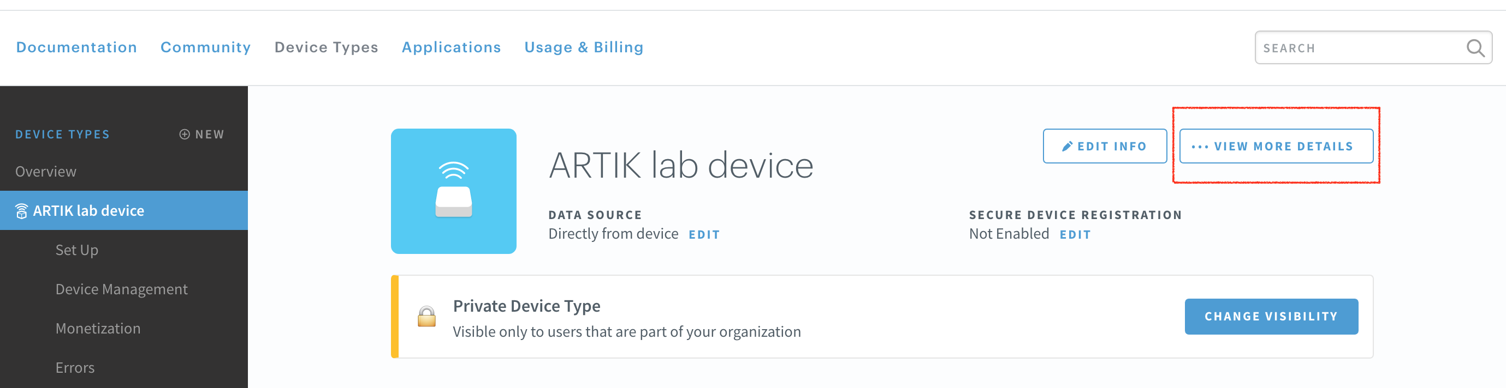

1. Make a note of the device type ID created. The Device type ID is dt­­­­__________________________ <please fill in>

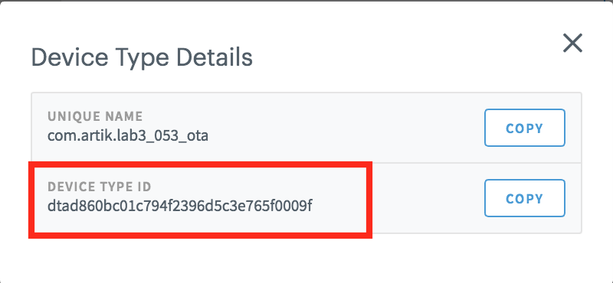

1. Congratulations you have successful represented your device in ARTIK Cloud.
2. On ARTIK 530s, run subscriber.js that listens for incoming messages from ARTIK055s,

[root@artik ~]# cd /home/

[root@artik ~]# nodejs mqtt.js YOUR_DEVICE_INSTANCE_DEVICE_ID

YOUR_DEVICE_INSTANCE_DEVICE_TOKEN

Device ID:7a1fb71xxxxxxxxxxxxxxxxx

Device Token: 72c660c6363xxxxxxxxxxx34908

Registered

Subscribed to MQTT broker

publish sensor data 516 to ARTIK Cloud

publish sensor data 468 to ARTIK Cloud

publish sensor data 636 to ARTIK Cloud

publish sensor data 608 to ARTIK Cloud

publish sensor data 2543 to ARTIK Cloud

publish sensor data 777 to ARTIK Cloud

From ARTIK Cloud portal, you will be able to visualize the data.

# Lab 3 Security API

Please refer to <https://developer.artik.io/documentation/artik/advanced-concepts/prepare-dev-env.html#locating-required-software> to install required security packages.